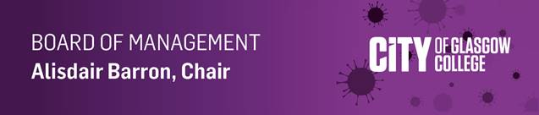

In these unprecedented and challenging times for us all, I felt it was important that I contact you directly, on behalf of the Board of Management. It’s hard to believe, I know, but it is just over five weeks since we closed our college campuses, with the exception of the two Halls of Residence, ahead of UK-wide lockdown. Both then and now, I believe that was absolutely the right thing, to keep focus on your safety and to look after your and our students’ health and wellbeing.

Like you, my colleagues and I have been kept regularly up to date by the Principal, who has also shared specific detail with us on the diligence paid to the support of vulnerable students in the halls, as well as day to day communications and the added challenge of some 1600 staff moving over to remote emergency teaching and learning at incredible speed.

On behalf of the Board of Management, I would like to say a huge thank you for your personal resilience, your hard work and your rising to the challenge of home/remote working, juggling work and family life, working with such professionalism at this time of dynamic crisis. I want to pay tribute especially to those members of Team City supporting our students in the Halls of Residence during lockdown and those securing and maintaining the college buildings in preparation for our eventual return.

I am heartened that we have such a dedicated ELT and SMT who have been meeting twice a week since closure and I am sure that you share my confidence in their compassionate and committed leadership and genuine support available to you throughout this emergency.

Our Board has a vital role to play at this critical time and we too are adjusting to new ways of thinking and governing. Our Board Committees will therefore continue to meet, albeit virtually, through the current cycle of meetings. While the immediate needs of our students are our primary concern, our forward planning requires us to exhibit the agility, flexibility and adaptability expected of a successful supportive super college. We are turning our focus on how City of Glasgow College will respond to the new normal of a radically changed strategic and operating environment. That is essential if we are to continue to fulfil a pivotal national role in the economic and social recovery of our nation.

With expert and informed guidance from the Principal and SMT, we will give serious consideration to transforming our learning and teaching practices, in line with government policy on social distancing. We also must wrestle with the huge financial implications that the coronavirus has brought to the college.

Clearly in the months ahead there is still a lot to be done to adapt to this new normal. My colleagues and I trust and intend that we will continue to do it together.

In the meantime, my thoughts are with you and yours. Please stay well and safe.

Kind regards

Alisdair Barron MBE
Chair, Board of Management

